**Word document**

Fahad Sheikh

University of Laurier

Windows programming

Heidar ali

april 11, 2023

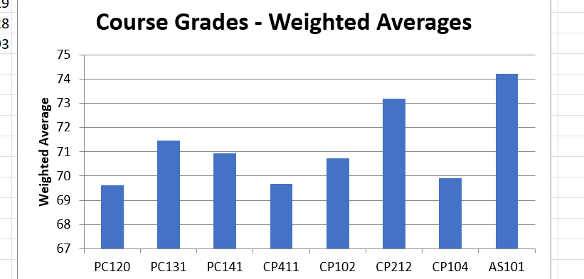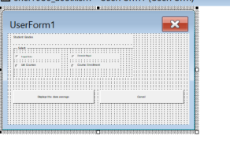

Instructions: As we can see from the pictures here you need to go on custom tabs and then press launch userform and then you have the option to do many things, just make sure to import all the data first.

In the first image you can see my histogram which compares each class's average based on its respective weight. The purpose of this is to see whose class is more and less and you can also use it to generate a word document to show each class's average. My excel sheet gets all of its data from access database and then uses it and formats it into my xlsm workbook and then from there i manipulate it and use it to generate data and results

In the second image you can see my userform which has huge buttons to make it easy for the user to access it. I also have each button for it to perform specific tasks such as display class average, create course grades chart and word doc about it or import data or list all the courses. It also has a huge cancel button to make it go away. My code has many comments to make it easy to understand and you will see that I try to use modular programming and error handling where it's needed in my code.